**Name Samiullah Khan (21-Arid-775)**

**Class BSSE 6A**

**Assignments Mobile App Development  
   
 Submitted to Sir Muhammad Azhar**

**Assignment No.1**

**Screenshot:**

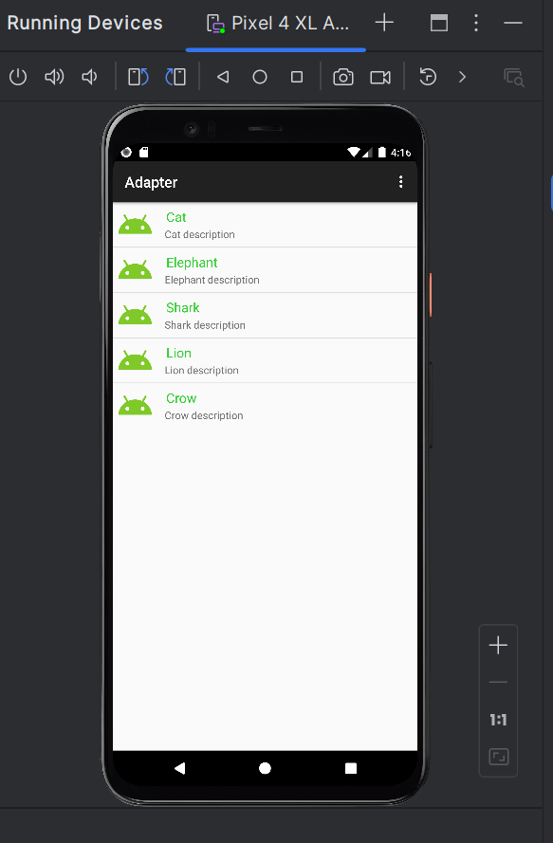

**Java Code:**

**🡺 MainActivity**

1. package com.example.adapter;  
     
   import androidx.appcompat.app.AppCompatActivity;  
     
   import android.os.Bundle;  
   import android.view.Menu;  
   import android.view.MenuItem;  
   import android.view.View;  
   import android.widget.AdapterView;  
   import android.widget.ListView;  
   import android.widget.Toast;  
     
   public class MainActivity extends AppCompatActivity {  
     
    int [] imagId = { R.drawable.*icon*, R.drawable.*icon*,R.drawable.*icon*, R.drawable.*icon*,  
    R.drawable.*icon*, };  
    String[] itemName = {"Cat", "Elephant",  
    "Shark", "Lion", "Crow"};  
    String [] itemDesc = {"Cat description", "Elephant description", "Shark description",  
    "Lion description","Crow description"};  
     
    @Override  
    protected void onCreate(Bundle savedInstanceState) {  
    super.onCreate(savedInstanceState);  
    setContentView(R.layout.*activity_main*);  
    CustomAdapter adapter = new CustomAdapter(this, imagId, itemName, itemDesc);  
    ListView list = (ListView) findViewById(R.id.*list*);  
    list.setAdapter(adapter);  
     
    list.setOnItemClickListener(new AdapterView.OnItemClickListener() {  
    @Override public void onItemClick(AdapterView<?> parent, View view, int position, long id) {  
    String SelectedItem= itemName[+position];  
    Toast.*makeText*(getApplicationContext(),  
    SelectedItem, Toast.*LENGTH_SHORT*).show();  
    } });  
     
     
    }  
    public boolean onCreateOptionsMenu(Menu menu) {  
    getMenuInflater().inflate(R.menu.*options*, menu);  
    return true;  
    }  
    @Override  
    public boolean onOptionsItemSelected(MenuItem item) {  
   // Handle item selection  
    int itemId = item.getItemId();  
    if (itemId == R.id.*opt*) {  
    Toast.*makeText*(this, item.getTitle(), Toast.*LENGTH_SHORT*).show();  
    return true;  
    } else if (itemId == R.id.*opt1*) {  
    Toast.*makeText*(this, item.getTitle(), Toast.*LENGTH_SHORT*).show();  
    return true;  
    } else if (itemId == R.id.*opt2*) {  
    Toast.*makeText*(this, item.getTitle(), Toast.*LENGTH_SHORT*).show();  
    return true;  
    }  
    return super.onOptionsItemSelected(item);  
     
    }}

**🡺 CustomerAdapter**

package com.example.adapter;  
  
import android.app.Activity;  
import android.content.Context;  
import android.view.LayoutInflater;  
import android.view.View;  
import android.view.ViewGroup;  
import android.widget.ArrayAdapter;  
import android.widget.ImageView;  
import android.widget.TextView;  
  
public class CustomAdapter extends ArrayAdapter<String> {  
  
 private final String[] itemName;  
 private final int[] imageId;  
 private final String[] itemDescription;  
 private final Context context;  
 public CustomAdapter(Activity context, int[] imgId, String[] itemNam, String[] itemDesc) {  
 super(context, R.layout.*listrow*, itemNam);  
 this.imageId = imgId;  
 this.itemName = itemNam;  
 this.itemDescription = itemDesc;  
 this.context=context;  
 }  
 public View getView(int position, View convertView, ViewGroup parent) {  
 View listItemView = convertView;  
 LayoutInflater inflater = (LayoutInflater)context.getSystemService(Context.*LAYOUT_INFLATER_SERVICE*);  
 listItemView = inflater.inflate(R.layout.*listrow*, parent, false);  
  
 ImageView imageView = (ImageView) listItemView.findViewById(R.id.*icon*);  
  
 TextView itemTitle = (TextView) listItemView.findViewById(R.id.*item*);  
 TextView descTextView = (TextView) listItemView.findViewById(R.id.*itemDesc*);  
 imageView.setImageResource(imageId[position]);  
 itemTitle.setText(itemName[position]);  
 descTextView.setText(itemDescription[position]);  
 return listItemView; };  
  
}

**Xml Code:**

**🡺 Activity_main.xml**

1. <?xml version="1.0" encoding="utf-8"?>  
   <LinearLayout xmlns:android="http://schemas.android.com/apk/res/android"  
    xmlns:app="http://schemas.android.com/apk/res-auto"  
    xmlns:tools="http://schemas.android.com/tools"  
    android:layout_width="match_parent"  
    android:layout_height="match_parent"  
    tools:context=".MainActivity"  
    android:orientation="vertical"  
    >  
     
    <ListView  
    android:id="@+id/list"  
    android:layout_width="match_parent"  
    android:layout_height="wrap_content"  
     
    >  
   </ListView>  
     
     
   </LinearLayout>

**🡺 Listrow.xml**

<?xml version="1.0" encoding="utf-8"?>  
<LinearLayout xmlns:android="http://schemas.android.com/apk/res/android"  
 android:layout_width="match_parent"  
 android:layout_height="match_parent"  
 android:orientation="horizontal"  
 >  
 <ImageView  
 android:id="@+id/icon"  
 android:layout_width="60dp"  
 android:layout_height="60dp"  
 android:padding="5dp" />  
 <LinearLayout android:layout_width="wrap_content"  
 android:layout_height="wrap_content"  
 android:orientation="vertical">  
 <TextView  
 android:id="@+id/item"  
 android:layout_width="wrap_content"  
 android:layout_height="wrap_content"  
 android:text="Medium Text"  
 android:textAppearance="?android:attr/textAppearanceMedium"  
 android:layout_marginLeft="10dp"  
 android:layout_marginTop="5dp"  
 android:padding="2dp"  
 android:textColor="#33CC33" />  
 <TextView  
 android:id="@+id/itemDesc"  
 android:layout_width="wrap_content"  
 android:layout_height="wrap_content"  
 android:text="Item Description"  
 android:layout_marginLeft="10dp"/>  
</LinearLayout>  
</LinearLayout>

**Assignment No.2**

**Screenshot:**

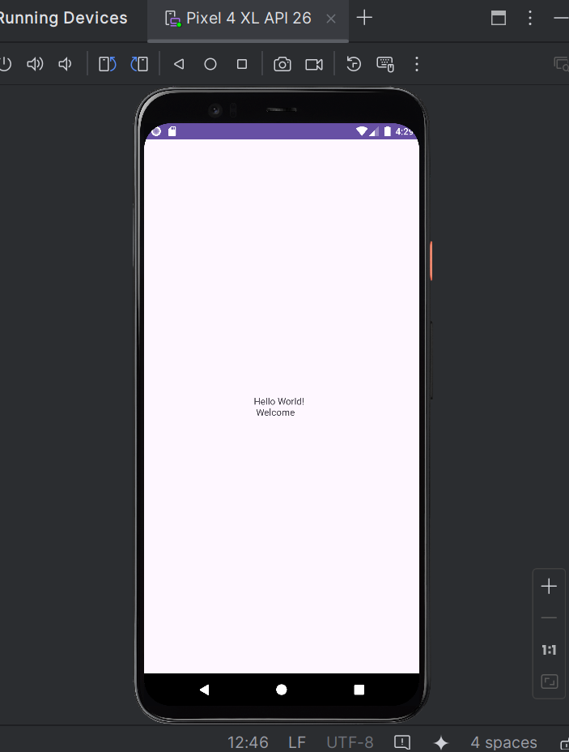

**Java Code:**

**🡺MainActivity**

package com.example.practiceapp;  
  
import androidx.appcompat.app.AppCompatActivity;  
  
import android.os.Bundle;  
  
public class MainActivity extends AppCompatActivity {  
  
 @Override  
 protected void onCreate(Bundle savedInstanceState) {  
 super.onCreate(savedInstanceState);  
 setContentView(R.layout.*activity_main*);  
 }  
}

**Xml Code:**

**🡺Activity_main.xml**

<?xml version="1.0" encoding="utf-8"?>  
<androidx.constraintlayout.widget.ConstraintLayout xmlns:android="http://schemas.android.com/apk/res/android"  
 xmlns:app="http://schemas.android.com/apk/res-auto"  
 xmlns:tools="http://schemas.android.com/tools"  
 android:layout_width="match_parent"  
 android:layout_height="match_parent"  
 tools:context=".MainActivity">  
  
 <TextView  
 android:layout_width="wrap_content"  
 android:layout_height="wrap_content"  
 android:text="Hello World! \n Welcome"  
  
 app:layout_constraintBottom_toBottomOf="parent"  
 app:layout_constraintEnd_toEndOf="parent"  
 app:layout_constraintStart_toStartOf="parent"  
 app:layout_constraintTop_toTopOf="parent" />  
  
</androidx.constraintlayout.widget.ConstraintLayout>

**Assignment No.3**

**Screenshot:**

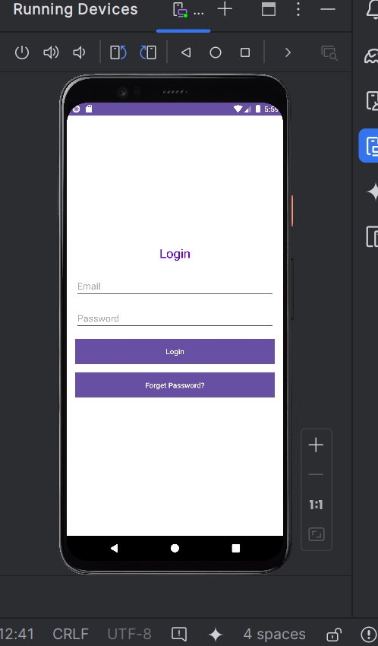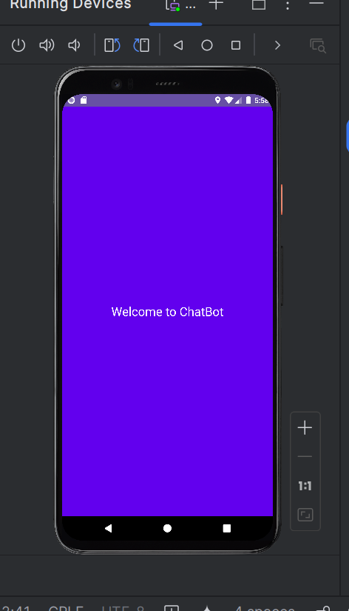

**Java Code:**

**🡺LoginActivity**

package com.example.loginapp;  
  
import android.os.Bundle;  
import androidx.appcompat.app.AppCompatActivity;  
  
public class LoginActivity extends AppCompatActivity {  
  
 @Override  
 protected void onCreate(Bundle savedInstanceState) {  
 super.onCreate(savedInstanceState);  
 setContentView(R.layout.*activity_login*);  
 }  
}

**🡺SplashActivity**

package com.example.loginapp;  
  
import android.content.Intent;  
import android.os.Bundle;  
import android.os.Handler;  
import androidx.appcompat.app.AppCompatActivity;  
  
public class SplashActivity extends AppCompatActivity {  
  
 @Override  
 protected void onCreate(Bundle savedInstanceState) {  
 super.onCreate(savedInstanceState);  
 setContentView(R.layout.*activity_splash*);  
  
 new Handler().postDelayed(new Runnable() {  
 @Override  
 public void run() {  
 Intent intent = new Intent(SplashActivity.this, LoginActivity.class);  
 startActivity(intent);  
 finish();  
 }  
 }, 3000); // 3 seconds delay  
 }  
}

**Xml Code:**

**🡺activity_login.xml**

<?xml version="1.0" encoding="utf-8"?>  
<LinearLayout xmlns:android="http://schemas.android.com/apk/res/android"  
 android:layout_width="match_parent"  
 android:layout_height="match_parent"  
 android:orientation="vertical"  
 android:padding="16dp"  
 android:gravity="center"  
 android:background="#FFFFFF">  
  
 <TextView  
 android:layout_width="wrap_content"  
 android:layout_height="wrap_content"  
 android:text="Login"  
 android:textSize="24sp"  
 android:textColor="#6200EE"  
 android:layout_marginBottom="24dp"/>  
  
 <EditText  
 android:id="@+id/email"  
 android:layout_width="match_parent"  
 android:layout_height="wrap_content"  
 android:hint="Email"  
 android:inputType="textEmailAddress"  
 android:layout_marginBottom="16dp"/>  
  
 <EditText  
 android:id="@+id/password"  
 android:layout_width="match_parent"  
 android:layout_height="wrap_content"  
 android:hint="Password"  
 android:inputType="textPassword"  
 android:layout_marginBottom="16dp"/>  
  
 <Button  
 android:id="@+id/loginButton"  
 android:layout_width="match_parent"  
 android:layout_height="wrap_content"  
 android:text="Login"  
 android:background="#6200EE"  
 android:textColor="#FFFFFF"  
 android:layout_marginBottom="16dp"/>  
  
 <Button  
 android:id="@+id/forgetButton"  
 android:layout_width="match_parent"  
 android:layout_height="wrap_content"  
 android:text="Forget Password?"  
 android:background="#6200EE"  
 android:textColor="#FFFFFF"  
 android:layout_marginBottom="16dp"/>  
</LinearLayout>

**🡺activity_splash.xml**

<?xml version="1.0" encoding="utf-8"?>  
<RelativeLayout xmlns:android="http://schemas.android.com/apk/res/android"  
 android:layout_width="match_parent"  
 android:layout_height="match_parent"  
 android:background="#6200EE"  
 android:gravity="center">  
  
 <TextView  
 android:id="@+id/welcomeText"  
 android:layout_width="wrap_content"  
 android:layout_height="wrap_content"  
 android:text="Welcome to ChatBot"  
 android:textSize="24sp"  
 android:textColor="#FFFFFF"  
 android:layout_centerInParent="true"/>  
</RelativeLayout>

**Assignment No.4**

**Screenshot:**

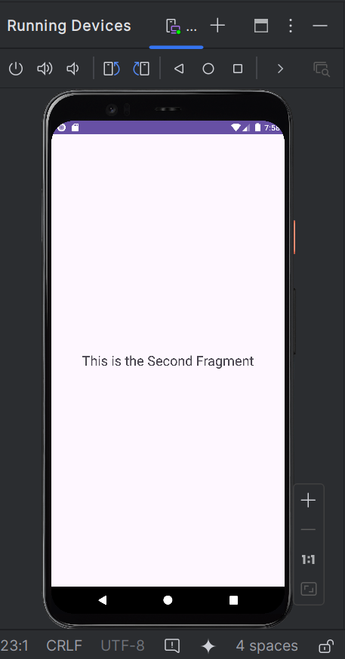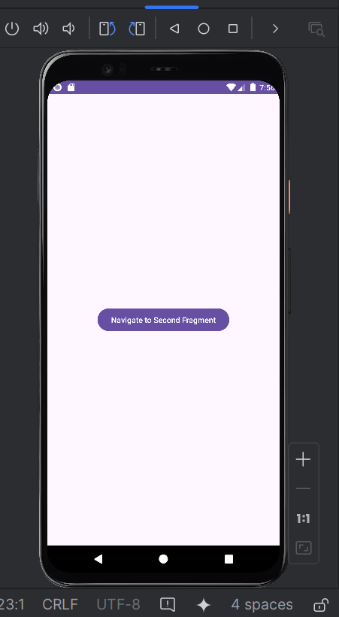

**Java Code:  
🡺 MainActivity**

package com.example.multifragmentapp;  
  
import android.os.Bundle;  
import androidx.appcompat.app.AppCompatActivity;  
import androidx.fragment.app.FragmentTransaction;  
  
public class MainActivity extends AppCompatActivity {  
 @Override  
 protected void onCreate(Bundle savedInstanceState) {  
 super.onCreate(savedInstanceState);  
 setContentView(R.layout.*activity_main*);  
  
 if (savedInstanceState == null) {  
 FirstFragment firstFragment = new FirstFragment();  
 getSupportFragmentManager().beginTransaction()  
 .add(R.id.*fragment_container*, firstFragment)  
 .commit();  
 }  
 }  
  
 public void navigateToSecondFragment() {  
 SecondFragment secondFragment = new SecondFragment();  
 FragmentTransaction transaction = getSupportFragmentManager().beginTransaction();  
 transaction.replace(R.id.*fragment_container*, secondFragment);  
 transaction.addToBackStack(null);  
 transaction.commit();  
 }  
}

**🡺FirstFragment**

package com.example.multifragmentapp;  
  
import android.os.Bundle;  
import androidx.fragment.app.Fragment;  
import android.view.LayoutInflater;  
import android.view.View;  
import android.view.ViewGroup;  
import android.widget.Button;  
  
public class FirstFragment extends Fragment {  
 @Override  
 public View onCreateView(LayoutInflater inflater, ViewGroup container,  
 Bundle savedInstanceState) {  
 View view = inflater.inflate(R.layout.*fragment_first*, container, false);  
  
 Button button = view.findViewById(R.id.*navigate_button*);  
 button.setOnClickListener(new View.OnClickListener() {  
 @Override  
 public void onClick(View v) {  
 ((MainActivity) getActivity()).navigateToSecondFragment();  
 }  
 });  
  
 return view;  
 }  
}

**🡺SecondFragment**

package com.example.multifragmentapp;  
  
import android.os.Bundle;  
import androidx.fragment.app.Fragment;  
import android.view.LayoutInflater;  
import android.view.View;  
import android.view.ViewGroup;  
  
public class SecondFragment extends Fragment {  
 @Override  
 public View onCreateView(LayoutInflater inflater, ViewGroup container,  
 Bundle savedInstanceState) {  
 return inflater.inflate(R.layout.*fragment_second*, container, false);  
 }  
}

**XML Code:**

**🡺activity_main.xml**

<?xml version="1.0" encoding="utf-8"?>  
<FrameLayout xmlns:android="http://schemas.android.com/apk/res/android"  
 android:layout_width="match_parent"  
 android:layout_height="match_parent"  
 android:id="@+id/fragment_container">  
</FrameLayout>

**🡺Fragment_first.xml**

<?xml version="1.0" encoding="utf-8"?>  
<FrameLayout xmlns:android="http://schemas.android.com/apk/res/android"  
 android:layout_width="match_parent"  
 android:layout_height="match_parent">  
  
 <Button  
 android:id="@+id/navigate_button"  
 android:layout_width="wrap_content"  
 android:layout_height="wrap_content"  
 android:text="Navigate to Second Fragment"  
 android:layout_gravity="center" />  
</FrameLayout>

**🡺Fragment_second.xml**

<?xml version="1.0" encoding="utf-8"?>  
<FrameLayout xmlns:android="http://schemas.android.com/apk/res/android"  
 android:layout_width="match_parent"  
 android:layout_height="match_parent">  
  
 <TextView  
 android:layout_width="wrap_content"  
 android:layout_height="wrap_content"  
 android:text="This is the Second Fragment"  
 android:layout_gravity="center"  
 android:textSize="24sp"/>  
</FrameLayout>

**GitHub Link for Assignments & final project:  
  
https://github.com/Samithecoder/Mobile--App--Development**